 | CHAROTAR UNIVERSITY OF SCIENCE & TECHNOLOGY  DEVANG PATEL INSTITUTE OF ADVANCE TECHNOLOGY AND RESEARCH | 

Weekly Report
In this report students require to mention the work has been done during the week and planning for the next week. (Please fill individual report for each week)

Student ID: 20DCE137 | Student Name: Parth Vaghela
From Date:23/05/2022 | To Date:28/05/2022
Semester:05 | Internship ID: RAO0107

Work done in last week (Attach supporting Documents):

1.Design web pages such as nutrition label, quiz, Tribute Page, Balance Sheet, Picasso Painting ,Piaano(source freecodecamp.org responsive Web design course )
2. design a company website using basic html & CSS.

Plans for next week:

1.going to start a new group project about video + audio
Player.

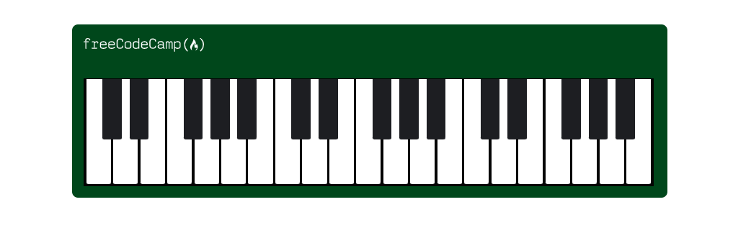
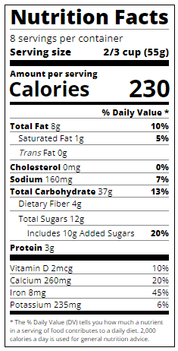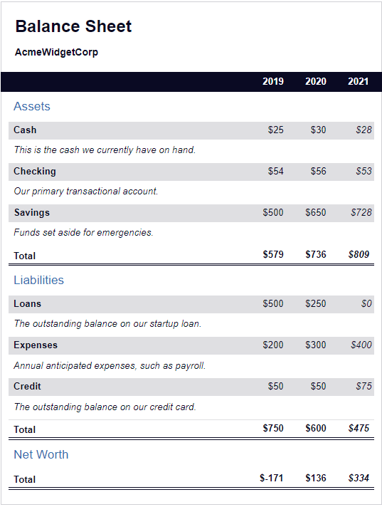
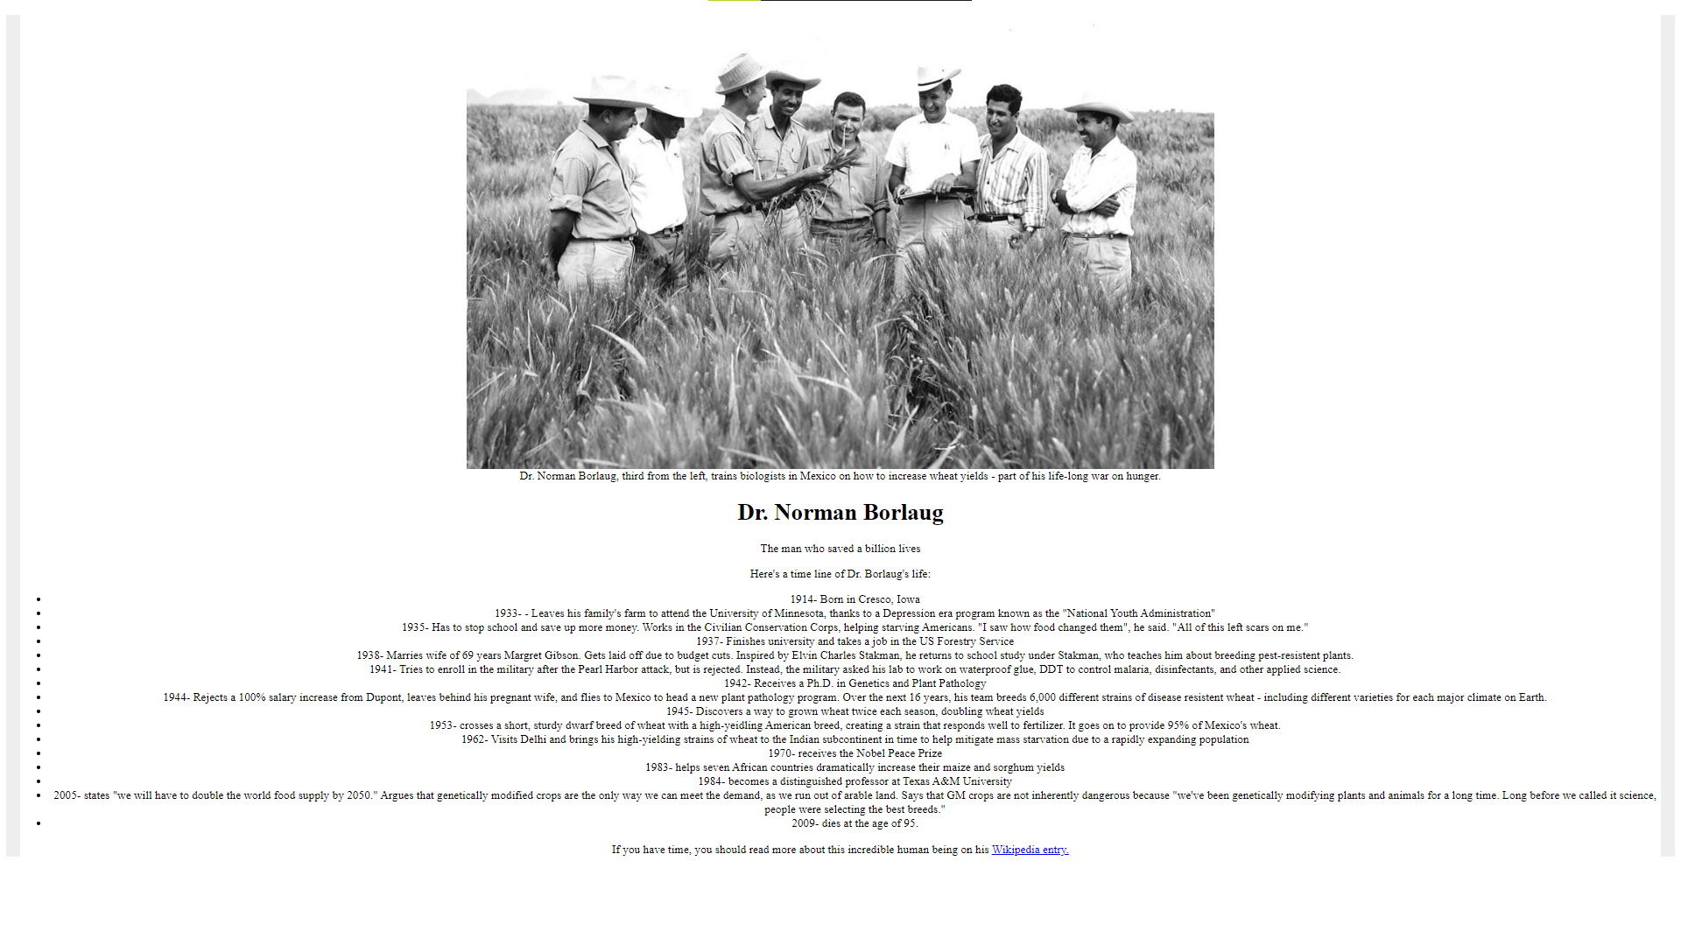
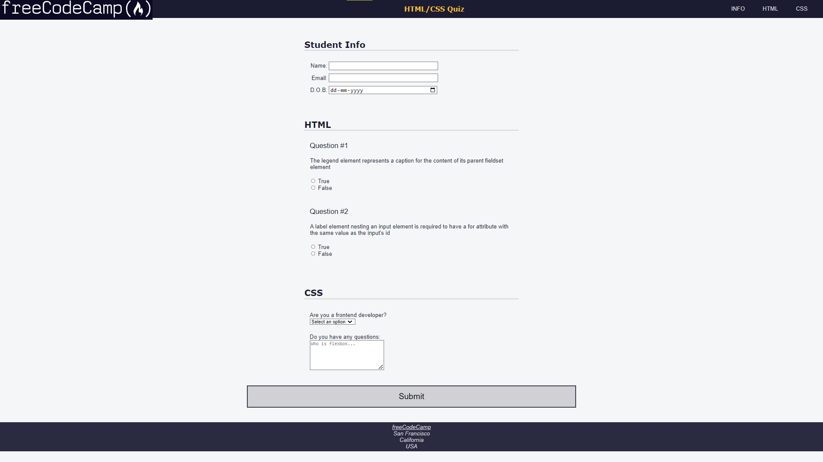
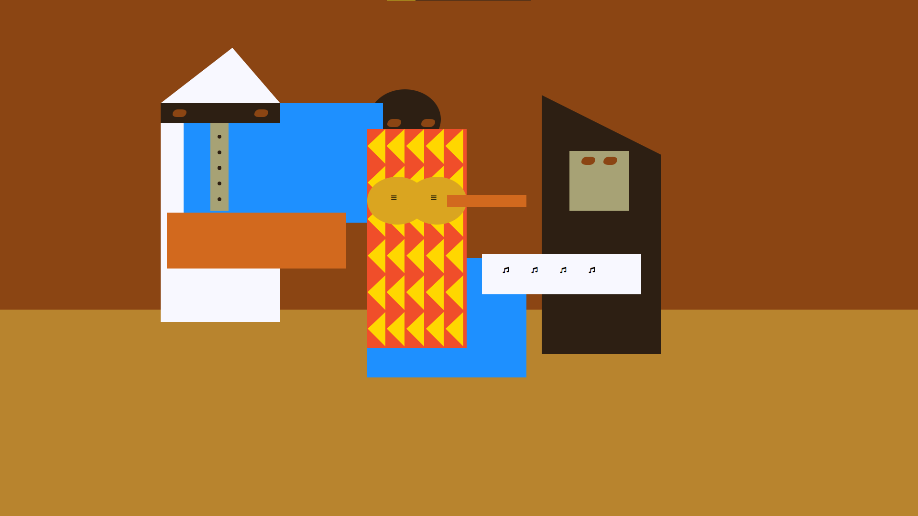

And company website design will be over a github account.(mention below)

Source code:

https://github.com/parth9104/Rao-Infotech-website-clone/branches

References:
https://www.w3schools.com/
https://www.freecodecamp.org/
https://raoinformationtechnology.com/

Signature of External Guide Signature of Internal Guide

